Policy for Supporting Pupils with Medical Conditions
St. Peter’s C of E Primary School

Updated: October 2021

Excellence In All We Do – Excellence In Who We Are – Excellence In Our Service With Others

This policy aims to provide clear guidance and procedures to staff, parents and pupils. It forms the basis of a supportive environment in which pupils with medical needs may receive suitable medical care enabling their continuing participation in education.

The key aims of the policy are to ensure that:

- Pupils at school with medical conditions are properly supported so that they have full access to education, including school trips and physical education.
- Consultation with appropriate persons is undertaken, such as health and social care professionals, parents and pupils to ensure the needs of children with medical conditions are fully considered.
- Pupils are kept safe from harm and abuse.
- Safe practices and procedures in place to ensure that the school meets its statutory responsibilities for health and safety.

The governing body is responsible for ensuring that there are sufficient arrangements to support pupils with medical conditions in school and for ensuring processes are in place to enable the policy to be developed and implemented.

The Headteacher is responsible for overseeing all of the arrangements in place and ensuring that the policy is implemented effectively. The Headteacher will designate relevant staff to carry out the specific roles within the policy and ensure that there are sufficient deputies to allow for staff absence.

Legislation and statutory responsibilities
This policy meets the requirements under Section 100 of the Children and Families Act 2014, which places a duty on governing boards to make arrangements for supporting pupils at their school with medical conditions.

It is also based on the Department for Education’s statutory guidance on supporting pupils with medical conditions at school.

Roles and responsibilities
The governing board
The governing board has ultimate responsibility to make arrangements to support pupils with medical conditions. The governing board will ensure that sufficient staff have received suitable training and are competent before they are responsible for supporting children with medical conditions.
The headteacher
The headteacher will:
- Make sure all staff are aware of this policy and understand their role in its implementation
- Ensure that there is a sufficient number of trained staff available to implement this policy and deliver against all individual healthcare plans (IHPs), including in contingency and emergency situations
- Ensure that all staff who need to know are aware of a child’s condition
- Take overall responsibility for the development of IHPs
- Make sure that school staff are appropriately insured and aware that they are insured to support pupils in this way
- Contact the school nursing service in the case of any pupil who has a medical condition that may require support at school, but who has not yet been brought to the attention of the school nurse
- Ensure that systems are in place for obtaining information about a child’s medical needs and that this information is kept up to date
Staff
Supporting pupils with medical conditions during school hours is not the sole responsibility of one person. Any member of staff may be asked to provide support to pupils with medical conditions, although they will not be required to do so. This includes the administration of medicines.
Those staff who take on the responsibility to support pupils with medical conditions will receive sufficient and suitable training, and will achieve the necessary level of competency before doing so.
Teachers will take into account the needs of pupils with medical conditions that they teach. All staff will know what to do and respond accordingly when they become aware that a pupil with a medical condition needs help.
Parents
Parents will:
- Provide the school with sufficient and up-to-date information about their child’s medical needs
- Be involved in the development and review of their child’s IHP and may be involved in its drafting
- Carry out any action they have agreed to as part of the implementation of the IHP, e.g. provide medicines and equipment, and ensure they or another nominated adult are contactable at all times

Pupils
Pupils with medical conditions will often be best placed to provide information about how their condition affects them. Pupils should be fully involved in discussions about their medical support needs and contribute as much as possible to the development of their IHPs. They are also expected to comply with their IHPs.

School nurses and other healthcare professionals
Our school nursing service will notify the school when a pupil has been identified as having a medical condition that will require support in school. This will be before the pupil starts school, wherever possible. They may also support staff to implement a child’s IHP.
Healthcare professionals, such as GPs and paediatricians, will liaise with the school’s nurses and notify them of any pupils identified as having a medical condition. They may also provide advice on developing IHPs.

Safeguarding

St. Peter’s is committed to the welfare and safeguarding of all pupils. This policy should be read in conjunction with our Safeguarding Policy.

Being notified that a child has a medical condition
When the school is notified that a pupil has a medical condition, the process outlined below will be followed to decide whether the pupil requires an Individual Healthcare Plans (IHPs).
The school will make every effort to ensure that arrangements are put into place within 2 weeks, or by the beginning of the relevant term for pupils who are new to our school.

Individual Healthcare Plans

IHPs will be drawn up where needs are complex or where it is necessary to clarify what support children require. When considering if an IHP is required the flow chart (Appendix B) can be used. The plan will be developed with the pupils’ best interests in mind to ensure that the risks to the child’s wellbeing, health and education are managed. Plans will be drawn up by the school in consultation with parents and medical professionals (as required).

The Head teacher is responsible for deciding, in consultation with staff, parents, health professionals and the Local Authority how the school can support a pupil with medical needs.

- The School First Aid Co-ordinator will be responsible for writing Individual Healthcare Plans in consultation with all relevant parties and ensure that information is disseminated to relevant staff on individual pupil’s needs as required, including any emergency procedures. This will be overseen by the SENCO. IHPs will be reviewed at least annually or when the child’s medical / health needs have changed.

- Medical information will be sought from the relevant medical professionals in order to inform the nature and content of the IHP

- Where a child has a special educational need or disability (SEND) identified in Education Health Care (EHC) plan, the IHP should be linked to or become part of that EHC plan.

- Where a child has special educational need or disability, but no EHC plan, their special educational needs should be mentioned in their IHP.

- The content of the Health Care Plan will follow the format as required in Appendix C, in order to ensure the required level of support is provided to adequately reflect the child’s medical needs.

- During visits off-site visits or extra-curricular activities the medical needs of pupils will be considered as part of the planning process and first aid requirements for the activity will take into account any medical or health care needs of the pupils taking part. Where required, sufficient essential medicines and health care plans will be taken as part of the activity and controlled by a suitable designated member of school staff. Individual pupil risk assessments will be undertaken where additional controls are required to reduce risk of accident or ill health during the visit/activity to an acceptable level. The child’s name will be clearly identified on the risk assessment.

Training

The Headteacher will ensure that staff are appropriately trained, including any whole school awareness training, and that individual staff are equipped to administer medical treatment to pupils with medical needs as required.

The strategic identification and co-ordination of training will be the responsibility of The School Business Manager and reviewed at least annually.

Staff involved in supporting pupils with medical conditions will be provided with general in-house training by the School First Aid Co-ordinator covering the school policy requirements and relevant school procedures. Staff must not give prescription medication or undertake health care procedures without training.

Where staff require additional training in order to deal with a specific medical condition, this will be undertaken by a school nurse or relevant health care professional as deemed necessary.

All training will be recorded (Appendix I). Staff training records with be managed by the School Business Manager and will be stored in the medical room.

Coordination of Information

The School First Aid Co-ordinator in conjunction with the SENCO will ensure that all relevant staff are aware of individual pupils’ medical needs and any emergency arrangements. The School First Aid Co-ordinator and SENCO will be responsible for coordinating and disseminating information as required. Teaching staff will inform the next years teachers during hand-over meetings in preparation for transition.

Long Term Medical Absence

Where pupils are absent for 15 days for medical reasons or more (either consecutively or cumulatively) they will be considered to have long term medical absence.

All cases of long term medical absence will be supported by a multi-agency approach. This multi-agency response and planning will, as a minimum, involve school staff, a representative from the local authority, a healthcare professional as well as parents/carers. The Deputy Head or Designated Teacher will be responsible for supporting the child which could involve a multi-agency response to a long term medical absence, including completing a referral to Tuition when a child is too ill to attend school.

Managing Medications

- Medicines will only be administered at school when it would be detrimental to a child’s health or their attendance not to do so. Where clinically possible medicines should be prescribed in dose frequencies which enable them to be taken outside of school hours.

- Each request for administration of medication to a pupil in school will be considered individually. No medication will be administered without prior consultation with, and written permission from the parent or guardian (Appendix D).

- A minimum amount of medication, required by the pupil, will be held in school to accommodate the needs of that pupil. Any surplus medication will be returned to the parents to arrange for safe disposal.

- Medicines received will be logged onto the school's drug file, and held securely within the school. All essential staff will be able to access medicines in case of emergency. Pupils will be informed of who to go to in order to access their medication and where it is stored.

- Medication must be delivered to school by the parent or responsible person (not sent to school in the child's bag) and given to Admin Team (E.g. the Headteacher or other designated person) where it will be signed in using Appendix H. The exception would be where there is signed agreement for the pupil to carry their own medication (Appendix E).

- Medicines brought into school should be in original packaging and clearly marked on a label by the dispenser with:-
- the name of the medicine
- the pupil's name
- dosage (including method of administration and times)
- any special storage requirements
- date

The school will establish a medication chart, used in conjunction with the pupil's Individual Health Care Plan (Appendix E) or Appendix G for individuals without an IHP. Persons administering medication will check medication type is correct then log the time and date, and sign the chart upon administering medication (See Appendix F)

Some pupils may be competent to manage their own medication e.g. inhalers. This will be discussed with parents where it is felt that this is appropriate. Permission must be obtained from parents by completing the form ‘Request for a pupil to carry his/her own medication’ (Appendix E). Where a pupil has an Individual Health Care Plan the method of administration will be detailed within this document.

Unacceptable practice

The governing body is responsible for ensuring that there are sufficient arrangements to support pupils with medical conditions in school and for ensuring processes are in place to enable the policy to be developed and implemented.

Staff recognise their duty under the DfE statutory guidance Supporting Pupils at School at School with Medical Conditions and are committed to upholding best practice

The following examples would be considered unacceptable practice:

- Pupils will not be prevented from easily accessing their inhalers and required medication
- Assuming every child with the same condition requires the same treatment
- Ignoring views of parents or pupils
- Sending pupils home frequently or preventing them from staying for normal school activities (unless specified in their IHP)
- Sending unwell pupils to the school office unaccompanied
- Penalising children for their attendance if justifiably related to their medical condition, e.g. hospital appointments
- Preventing pupils from drinking, eating or taking breaks in order to manage their medication
- Requiring parents to attend school to provide medical support
- Preventing children from participating, or creating unnecessary barriers, in any aspect of school life, including school trips.

Complaints

Should parents or pupils be dissatisfied with the support provided they should discuss their concerns directly with the Headteacher. If for whatever reason this does not resolve the issue the school’s complaints procedure should be followed.

Approved by: | Local Governing Body on 22nd October 2021
Last reviewed on: | 11th October 2021 by Lynne McCullough and 13th to 22nd October 2021 by LGB  Previously - reviewed by LGB on 7th October 2020
Next review due by: | October 2022

Appendix A

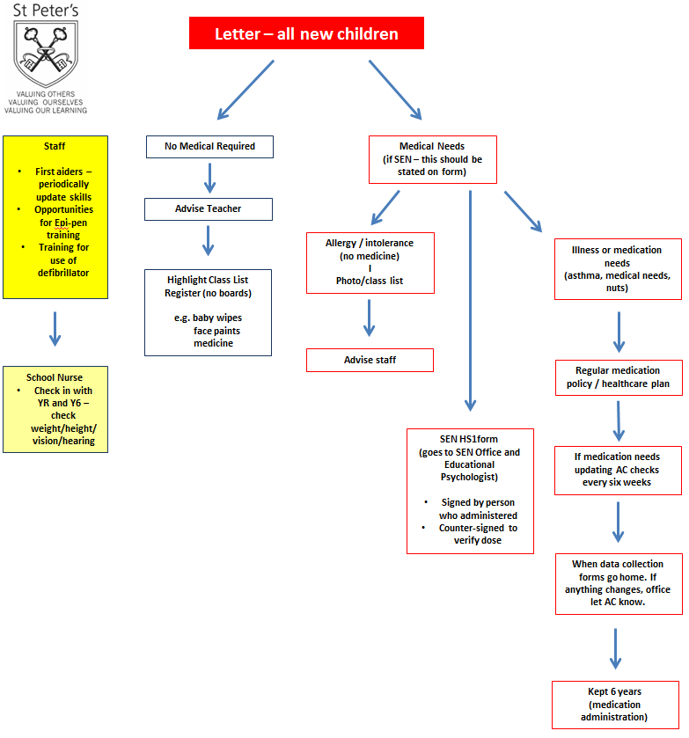

Appendix B
